Tech Check

Instructions
- Complete all the questions listed below.
- Post this document that is updated with the required screenshots by the due date listed on the syllabus for full credit.
NOTE: many students work on this assignment and type the answers in this document, then they post the answers to the discussion board when they have completed the assignment.
Overview | Madison College has some software that will be useful to you as a student. This assignment has you download and install the software on your personal device. You will also join the IT Guides team. This is a place to get help from other students in IT courses.
Completion time | 60 minutes

Assignment Details
Student Email
- Click on this link in your browser to go to Outlook Email: https://outlook.office.com/mail/inbox
- Login with your Madison College email @madisoncollege.edu username and password
- You should check your student on a regular basis (I recommend daily – Monday – Friday). Your student email is the official way that instructors communicate with their students. You may miss some messages if you are not checking this regularly.
- Do you need help with email? Here’s a guide for using email at Madison College: https://libguides.madisoncollege.edu/technology/email/view

Microsoft Office 365 Install
NOTE: This software is only valid while you are a student at Madison College.
- This software will allow you to use Word, Excel, Teams, Access, PowerPoint and other Microsoft Office products while you are a student at Madison College.
- Click on this link in your browser to go to the guide to install Microsoft Office 365 on your own computer: https://libguides.madisoncollege.edu/technology/software/office365
- Login to your student email with your Madison College email @madisoncollege.edu username and password
- Follow the directions from the Install Guide (link above) for “How To Install Microsoft 365 – PC (Windows)
- Do you need help with email? Here’s a guide for using email at Madison College: https://libguides.madisoncollege.edu/technology/email/view

OneDrive Install
NOTE: This software is only valid while you are a student at Madison College.
- Office 365 includes OneDrive (cloud storage for your files)
- This will allow you to save your files for classes and collaborate with other students/staff/faculty
- Click on this link in your browser to go to the guide to install OneDrive on your own computer: https://libguides.madisoncollege.edu/technology/onedrive
- Follow the directions under “Access OneDrive” for the App Launcher to access your OneDrive files
- Install OneDrive to your computer with this link: https://onedrive.com/
  - Login with your Madison College email @madisoncollege.edu username and password

MS Teams Install
NOTE: This software is only valid while you are a student at Madison College.
- Office 365 includes MS Teams (for video conferencing)
- Click on this link in your browser to go to the guide to install MS Teams on your own computer: https://libguides.madisoncollege.edu/technology/teams
- Follow the directions under “Accessing Microsoft Teams” for the App Launcher to use MS Teams
- We recommend that you Download the Windows App and install it on your home computer
- You will use MS Teams to complete the remainder of this assignment.

Navigating to MS Teams
- Click on this link Join our IT Guide Teams site: Join IT Guides
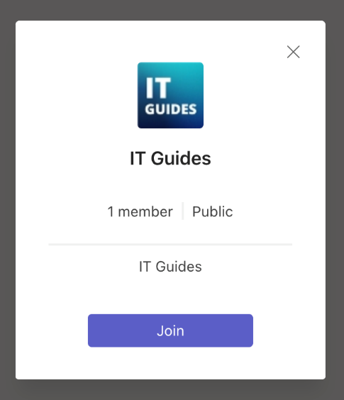
- Then click on Join
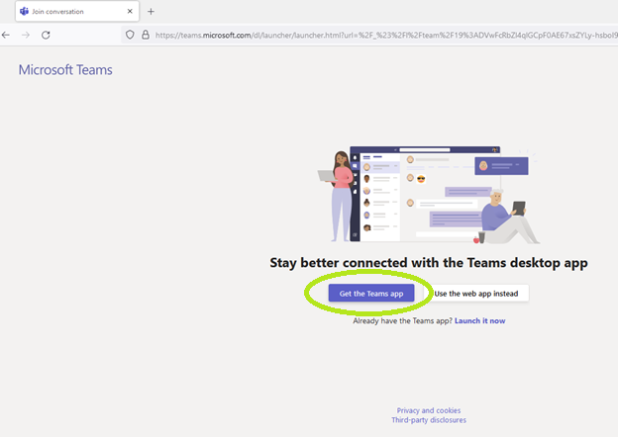
- If you have Microsoft Teams installed, you can “Launch it Now” otherwise, you can click on “Get the Teams app” button in your browser. This should open Microsoft Teams in your browser. It should automatically go to the IT Guides Team.
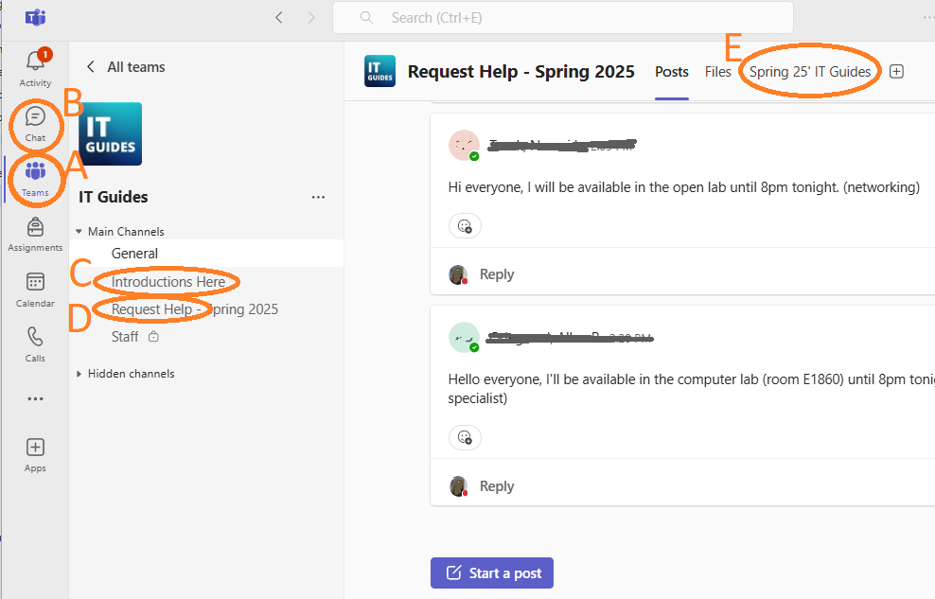
  - A – List of your “Teams” in Microsoft Teams
  - B – Chat – This is where you will see a Direct Message from an IT Guide
  - C – Introductions Here – This is where you post your introduction for the Exploration of IT class
  - D – Request Help – Student and IT Guide channel for questions and assistance.
  - E – Most recent IT Guide/student schedule
- If you need additional help using Teams, https://libguides.madisoncollege.edu/technology/teams
- Post in the channel that says, “Introductions Here” and introduce yourself.
  - Introduce yourself or something like, ‘Hi, I am yourname. I am introducing myself for the IT Security Awareness course’
  - Please note that you will not get a response from the introduction of yourself.
- After posting your introduction - take a screen shot showing the post in Teams and paste it below.
Screenshot 1

- Now – find the schedule for the IT Guides – take a screenshot showing the open schedule and paste it below
Screenshot 2

- Save this document, then turn it in or submit this document to Brightspace

Review
When your assignment is complete, make sure you go back and review your completed assignment in Brightspace. If you are missing a portion of one of the questions, you can submit the assignment again. This must be completed by the due date listed on your syllabus for full credit.

